EXPERIMENT NO. 5

AIM: To study and Install Docker for containerization.
Theory:
- Docker is a software containerization platform, meaning you can build your application, package them along with their dependencies into a container and then these containers can be easily shipped to run on other machines.
- These containers use Containerization which can be considered as an evolved version of Virtualization. The same task can also be achieved using Virtual Machines; however, it is not very efficient. Docker is gaining popularity and its usage is spreading like wildfire. The reason for Docker’s growing popularity is the extent to which it can be used in an IT organization.
- Virtualization is the technique of importing a Guest operating system on top of a Host operating system. Virtualization also has some shortcomings. Running multiple Virtual Machines in the same host operating system leads to performance degradation.
- Another problem with Virtual Machines which uses virtualization is that it takes almost a minute to boot-up. This is very critical in case of real-time applications.
- Containerization is the technique of bringing virtualization to the operating system level. While Virtualization brings abstraction to the hardware, Containerization brings abstraction to the operating system.
- Do note that Containerization is also a type of Virtualization. Containerization is however more efficient because there is no guest OS here and utilizes a host’s operating system, share relevant libraries & resources as and when needed unlike virtual machines. Application specific binaries and libraries of containers run on the host kernel, which makes processing and execution very fast. Even booting-up a container takes only a fraction of a second.
- Because all the containers share, host operating system and holds only the application related binaries & libraries. They are lightweight and faster than Virtual Machines.
- On Docker, each application will run on a separate container and will have its own set of libraries and dependencies. This also ensures that there is process level isolation, meaning each application is independent of other applications, giving developers surety that they can build applications that will not interfere with one another.

Installation of Docker:
- Installing required packages: Curl and setting up docker packages
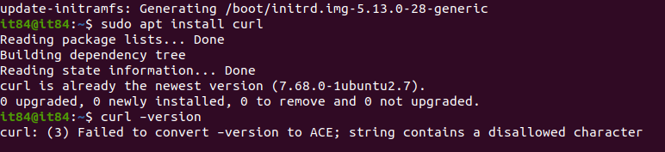
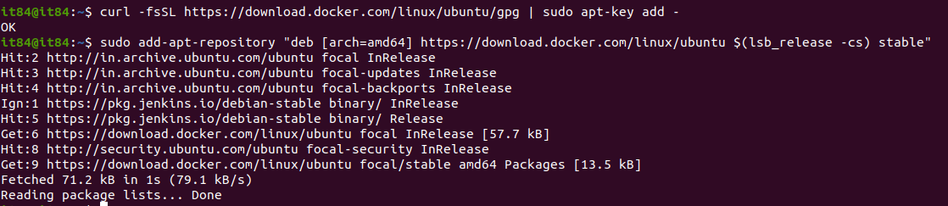
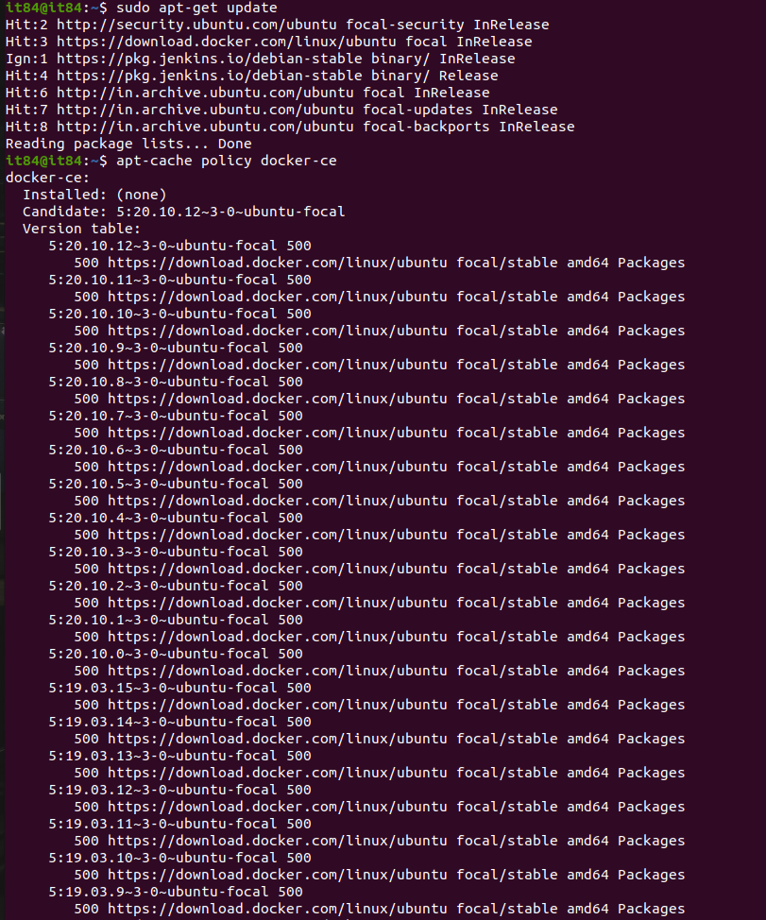
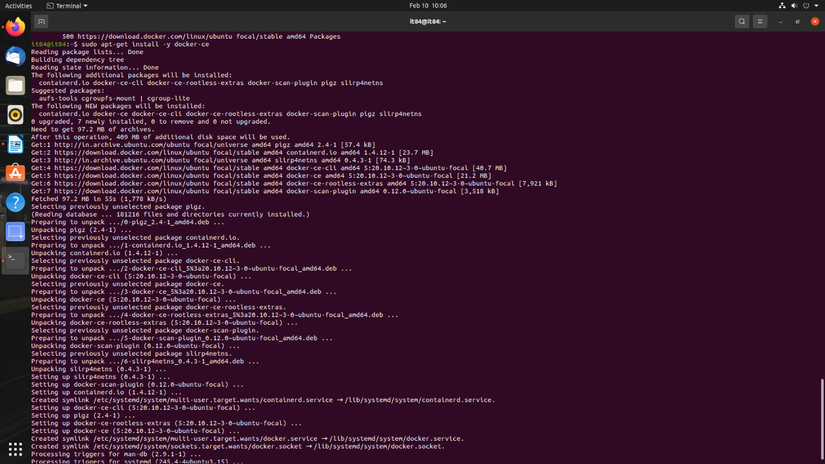
- Checking the version of installed Docker
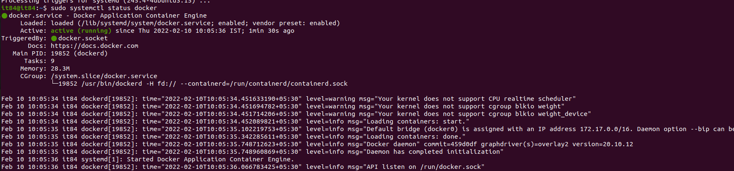
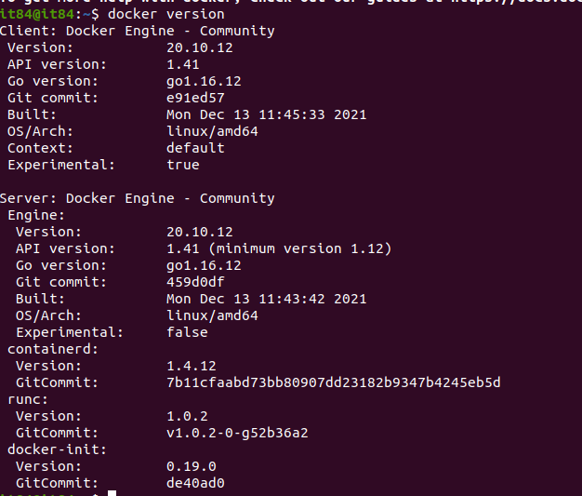
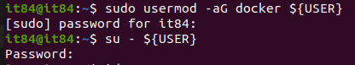
- Running an image after pulling it from Docker Hub
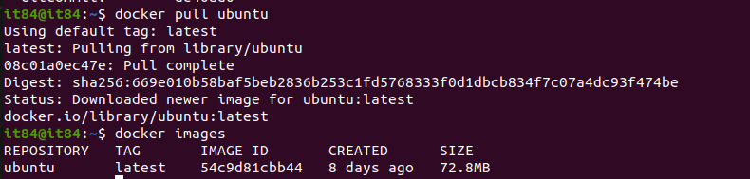
- Image Example
- Docker MySQL Image
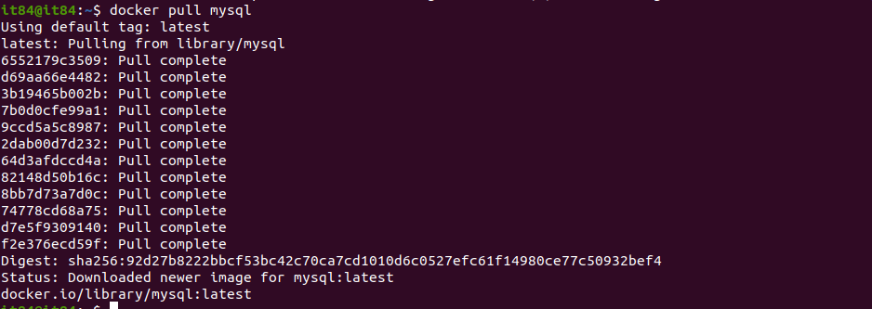
- Setting up Docker Services
- Configuring Proxy for Docker
- Displaying all containers in the system
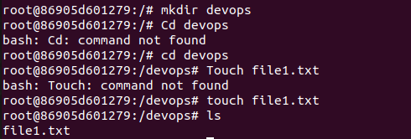
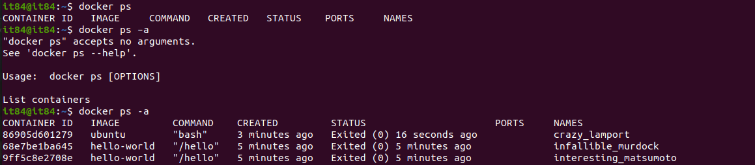
- Container Operations: Executing, Running and Killing a Container
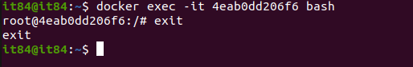
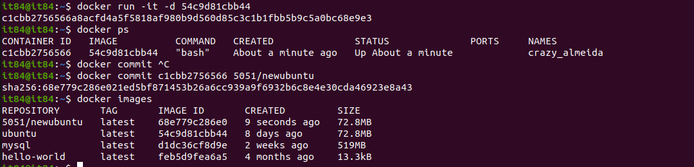
- Logging into Docker Hub
- Displaying all docker images in the system
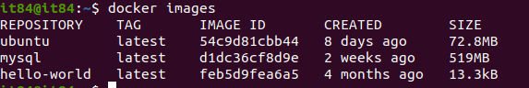
- Running an image named “Hello-World”

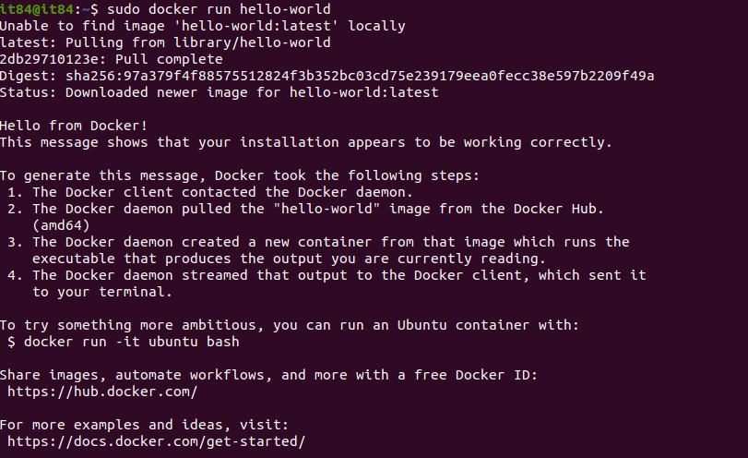
Conclusion: Thus, we have successfully studied and installed Docker.

